Blood test markers to diagnose advanced fibrosis in Southeast Asia patients with non-alcoholic fatty liver disease

Chao Sang1#, Hong-Mei Yan 2,3,#, Wah Kheong Chan4, Xiao-Peng Zhu2, Tao Sun1, Xin-Xia Chang2, Ming-Feng Xia2, Xiao-yang Sun2, Xi-Qi Hu5, Xin Gao2,3, Wei Jia1,6, Hua Bian2,3,*, Tianlu Chen1*, Guoxiang Xie7*

**Table S1.** Clinical and demographical characteristics of the NAFLD validation sets.

|  |  |  |  |  |
| --- | --- | --- | --- | --- |
| **a) Validation set1** | | | | |
| **Characteristics** | **All (n=147)** | **Early fibrosis (S0-2) (n=116)** | **Advanced fibrosis (S3-4) (n=31)** | **p value** |
| **Age (Year)** | 50.48±11.65 | 48.66±11.84 | 57.29±7.96 | **<0.001** |
| **ALB (g/L)** | 4.13±0.32 | 4.17±0.29 | 4.01±0.40 | 0.050 |
| **ALT (IU/L)** | 82.99±47.08 | 79.54±44.99 | 95.9±53.04 | 0.100 |
| **AST (IU/L)** | 50.22±28.64 | 45.57±25.34 | 67.61±33.70 | **<0.001** |
| **BMI (kg/m2)** | 29.32±4.53 | 29.28±4.66 | 29.46±4.04 | 0.879 |
| **FBG (mmol/L)** | 6.34±2.17 | 6.09±2.14 | 7.25±2.09 | **<0.001** |
| **GGT (IU/L)** | 102.82±87.39 | 89.24±71.46 | 153.65±119.22 | **<0.001** |
| **HbA1c (%)** | 6.55±1.48 | 6.35±1.43 | 7.28±1.45 | **0.001** |
| **HDL (mmol/L)** | 1.15±0.26 | 1.13±0.23 | 1.22±0.34 | 0.265 |
| **LDL (mmol/L)** | 3.07±1.02 | 3.13±0.99 | 2.87±1.11 | 0.191 |
| **PLT (10^9/L)** | 262.03±63.61 | 272.46±59.73 | 223.03±63.44 | **<0.001** |
| **TBIL (μmol/L)** | 12.75±7.10 | 12.89±7.60 | 12.23±4.86 | 0.684 |
| **TC (mmol/L)** | 4.98±1.15 | 5.03±1.07 | 4.78±1.40 | 0.341 |
| **TG (mmol/L)** | 1.73±0.74 | 1.75±0.79 | 1.65±0.48 | 0.945 |
| **AST/ALT** | 0.64±0.25 | 0.61±0.19 | 0.78±0.39 | **0.002** |
| **AST/PLT** | 0.52±0.35 | 0.45±0.29 | 0.81±0.42 | **<0.001** |
| **DM.IFG (NO/YES)** | 67:80 | 63:53:00 | 4:27 | **<0.001** |
| **Sex (M/F)** | 80:67 | 65:51:00 | 15:16 | 0.578 |
| **b) Validation set2** | | | | |
| **Characteristics** | **All (n=97)** | **Early fibrosis (S0-2) (n=65)** | **Advanced fibrosis (S3-4) (n=32)** | **p value** |
| **Age (Year)** | 57.29±10.08 | 56.65±10.53 | 58.59±9.11 | 0.580 |
| **ALB (g/L)** | 4.03±0.35 | 4.04±0.35 | 4.01±0.35 | 0.702 |
| **ALT (IU/L)** | 43.80±28.09 | 38.97±26.61 | 53.62±28.87 | **0.003** |
| **AST (IU/L)** | 36.52±20.63 | 31.78±14.69 | 46.12±27.01 | **0.005** |
| **BMI (kg/m2)** | 30.62±4.45 | 30.33±4.21 | 31.21±4.93 | 0.401 |
| **FBG (mmol/L)** | 8.09±3.16 | 7.46±2.51 | 9.36±3.92 | **0.012** |
| **GGT (IU/L)** | 80.94±94.89 | 60.78±52.05 | 121.88±140.39 | **0.011** |
| **HbA1c (%)** | 7.64±1.54 | 7.34±1.29 | 8.25±1.82 | **0.017** |
| **HDL (mmol/L)** | 1.20±0.27 | 1.18±0.27 | 1.24±0.28 | 0.350 |
| **LDL (mmol/L)** | 2.30±0.77 | 2.22±0.72 | 2.46±0.85 | 0.187 |
| **PLT (10^9/L)** | 269.27±70.91 | 276.38±73.14 | 254.81±64.84 | 0.145 |
| **TBIL (μmol/L)** | 10.18±4.81 | 10.11±4.95 | 10.31±4.60 | 0.597 |
| **TC (mmol/L)** | 4.35±1.03 | 4.23±0.81 | 4.6±1.35 | 0.333 |
| **TG (mmol/L)** | 1.88±1.14 | 1.86±0.93 | 1.92±1.49 | 1.000 |
| **AST/ALT** | 0.91±0.28 | 0.93±0.30 | 0.89±0.24 | 0.464 |
| **AST/PLT** | 0.37±0.24 | 0.31±0.15 | 0.49±0.32 | **0.004** |
| **DM.IFG (NO/YES)** | 0.477083333 | 8:57 | 2:30 | 0.489 |
| **Sex (M/F)** | 43:54:00 | 34:31:00 | 9:23 | **0.042** |

Note: Values were expressed as mean ± SD.

P value determined by comparing characteristics of individuals with early (fibrosis stage 0-2) and advanced fibrosis (fibrosis stage 3-4) were evaluated using an independent samples t-test or Wilcoxon-Mann-Whitney test. χ2 test or Fisher s exact test, when appropriate, was used to compare categorical variables. Bold indicates significant p values <0.05.

ALB, Albumin; ALT, alanine transaminase; AST, aspartate transaminase; BMI, Body Mass Index; FBG, fasting blood glucose; GGT, gamma-glutamyl transferase; HbA1c, glycated hemoglobin; HDL, high-density lipoprotein; LDL, low-density lipoprotein; PLT, platelet; TBIL, total bilirubin; TC, total cholesterol; TG, triglyceride; DM.IFG, presence of diabetes or impaired fasting glycemia.

**Figure S1.** Scatter plot of optimal parameter set selection in model construction

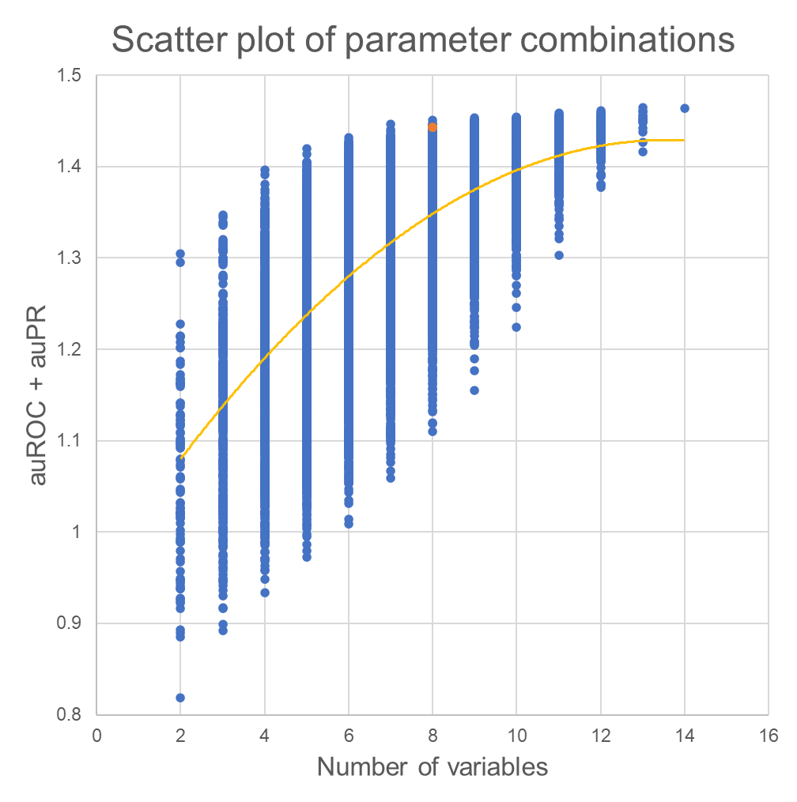

Note: The optimal parameter set were showed by the orange dots. It was selected not only according to the sum of auROC and auPR, but also the criteria about accuracy, sensitivity and F1 score.